Software Design Description

for

TMC Entrance Examination Answer Sheet Recognition and Scoring System

List of Figures
Figure No. | Description | Page
Figure 1.0 | Login Class Diagram | 4
Figure 2.0 | Dashboard Class Diagram | 4
Figure 3.0 | User Account Class Diagram | 5
Figure 4.0 | Applicant Class Diagram | 5
Figure 5.0 | Examination Folder Class Diagram | 6
Figure 6.0 | Answer Key Class Diagram | 6
Figure 7.0 | Answer Sheet Class Diagram | 7
Figure 8.0 | Examination Result Class Diagram | 7
Figure 9.0 | AI-based Answer Sheet Recognition Home Scanner Class Diagram | 8
Figure 10.0 | Entity-Relationship Diagram | 22
Figure 11.0 | Login Sequence Diagram | 23
Figure 12.0 | Dashboard Sequence Diagram | 23
Figure 13.0 | User Account Sequence Diagram | 24
Figure 14.0 | Identify Applicant Sequence Diagram | 25
Figure 15.0 | Examination Folder Sequence Diagram | 26
Figure 16.0 | Answer Key Sequence Diagram | 27
Figure 17.0 | Answer Sheet Sequence Diagram | 28
Figure 18.0 | Examination Result Sequence Diagram | 28
Figure 19.0 | AI Based Answer Sheet Recognition Home Scanner | 29

List of Tables

Table No. | Description | Page
Table 1.0 | Definition, Acronyms, and Abbreviations | 2
Table 2.0 | Answer Key Items | 9
Table 3.0 | Answer Keys | 10
Table 4.0 | Answer Sheets | 11
Table 5.0 | Applicant Answers | 12
Table 6.0 | Audit Logs | 13
Table 7.0 | Examination Folders | 14
Table 8.0 | Examination Result | 16
Table 9.0 | OMR Processing Jobs | 17
Table 10.0 | System Settings | 18
Table 11.0 | Users | 19
Table 12.0 | Exam Applicants | 20

Introduction

Purpose

This document aims to present the design and progress of the TMC Entrance Examination Answer Sheet Recognition and Scoring System for Trinidad Municipal College. This further explains the description of the software system design. The general structural designs as well as the current project status are highlighted in this report.

Scope
This document describes the system design for the TMC Entrance Examination Answer Sheet Recognition and Scoring System. It describes how the application will be constructed, by specifying the components to be used, how they will be organized in relation to each other, and the general principles of the application's internal construction.
The following are functionalities covered by the TMC Entrance Examination Answer Sheet Recognition and Scoring System:
Admissions Office Personnel / Administrators
- System Management: Create and manage user accounts, roles, and system-wide configurations.
- Answer Key Management: Create and edit answer keys for examinations.
- Dashboard: View overview of applicants, total examinations conducted, passing statistics, and recent activities.
Entrance Examination Staff
- AI-Based Answer Sheet Recognition: Scan uploaded answer sheets and utilize AI-powered Optical Mark Recognition (OMR) for automatic answer detection.
- Score Computation: Automatically compute examination scores with instant pass/fail determination.
- Result Management: View and manage examination results.
- Mobile Access: Scan answer sheets using the phone camera.

Definition, Acronyms, and Abbreviations
Terms | Definition
AI | Artificial Intelligence - Computers that can think and learn like humans. Used here to read and understand scanned answer sheets.
Andriod | A mobile operating system by Google. The mobile app in this project runs on this platform.
Class Diagram | A picture that shows the classes, their parts, actions, and how they relate to each other in a system.
ERD | A picture that shows how data entities relate to each other.
OMR | Optical Mark Recognition - A technology that detects marks on a scanned image.
SDD | Software Design Description
Sequence Diagram | A picture that shows how objects interact with each other over time.
TMC | Trinidad Municipal College - The school that will use this system.

Table 1.0 Definition, Acronym, and Abbreviations

References
[1] J. Muangprathub, O. Shichim, Y. Jaroensuk, and S. Kajornkasirat, (2018). "Automatic Grading of Scanned Multiple Choice Answer Sheets," International Journal of Engineering and Technology, vol. 7, no. 2. Available at: https://doi.org/10.14419/ijet.v7i2.23.11910
[2] C. Han, A. Krishna K., P. V., M. Castro, et al., (2025). "A Study and Implementation of Customizable Optical Mark Recognition Sheets for Assessments," 2025 IEEE Frontiers in Education Conference (FIE). Available at: https://doi.org/10.1109/FIE63693.2025.11328230
[3] X. Li, T. Yue, X. Huang, Z. Yang, and G. Xu, (2019). "BAGS: An Automatic Homework Grading System Using the Pictures Taken by Smart Phones," arXiv. Available at: https://arxiv.org/abs/1906.03767
[4] T. D. Quy, P. T. T. Nga, and N. V. H. Dung, (2021). "Application of Optical Mark Recognition Techniques to Survey Answer Sheets at Dalat University," Dalat University Journal of Science, vol. 11, no. 1, pp. 93–103. Available at: https://doi.org/10.37569/DalatUniversity.11.1.791
[5] Y. Hernández-Mier, M. A. Nuño-Maganda, S. Polanco-Martagón, G. Acosta-Villarreal, and R. Posada-Gómez, (2025). "Unsupervised Optical Mark Recognition on Answer Sheets for Massive Printed Multiple-Choice Tests," Journal of Imaging, vol. 11, no. 9, p. 308. Available at: https://doi.org/10.3390/jimaging11090308

System Architecture

Class Diagram

2.1.1. Login - A class diagram that depicts the structure of functions for validating user
credentials during logging in.
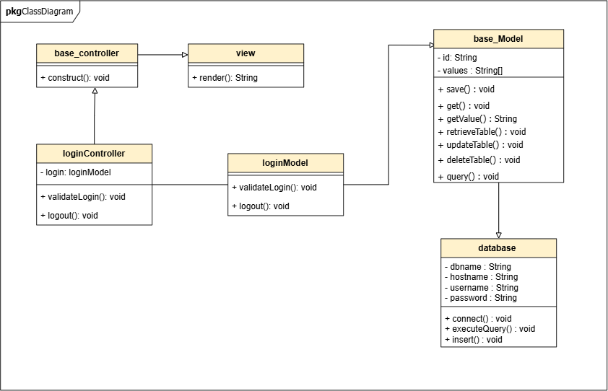
Figure 1.0 Login Class Diagram

2.1.2. Dashboard - A class diagram that depicts the structure of functions in retrieving data displayed in graphical representation for a better understanding of information.
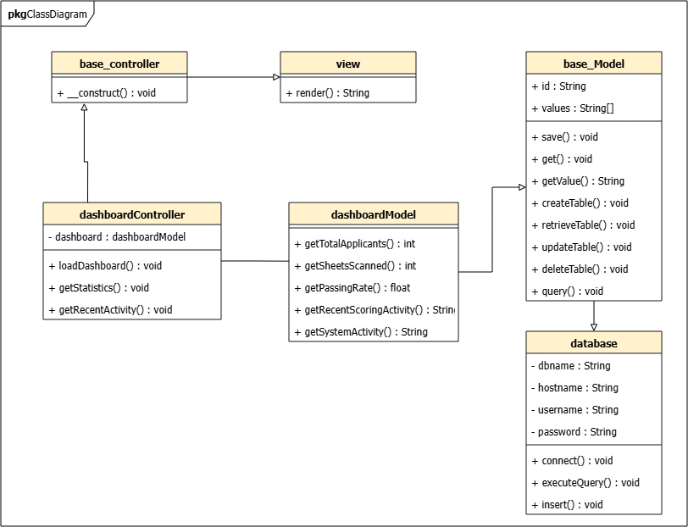
Figure 2.0 Dashboard Class Diagram
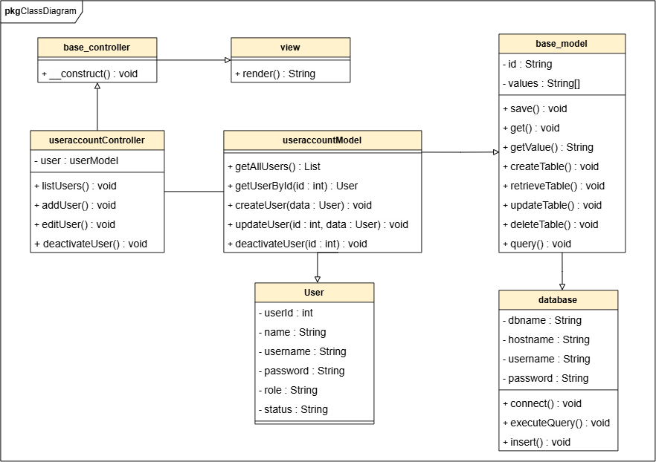
2.1.3. User Account- A class diagram that depicts the structure of functions in managing the system’s user accounts.
Figure 3.0 User Account Class Diagram

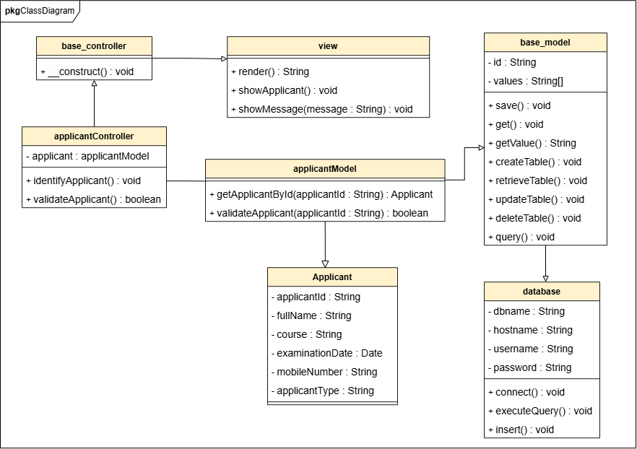
2.1.4. Applicant - A class diagram that depicts the structure of functions used to identify and retrieve an applicant’s examination information before proceeding with answer sheet processing.

Figure 4.0 Applicant Class Diagram

2.1.5. Examination Folder - A class diagram that depicts the structure of functions used to create, view, organize, and manage examination result folders according to the course and school year.
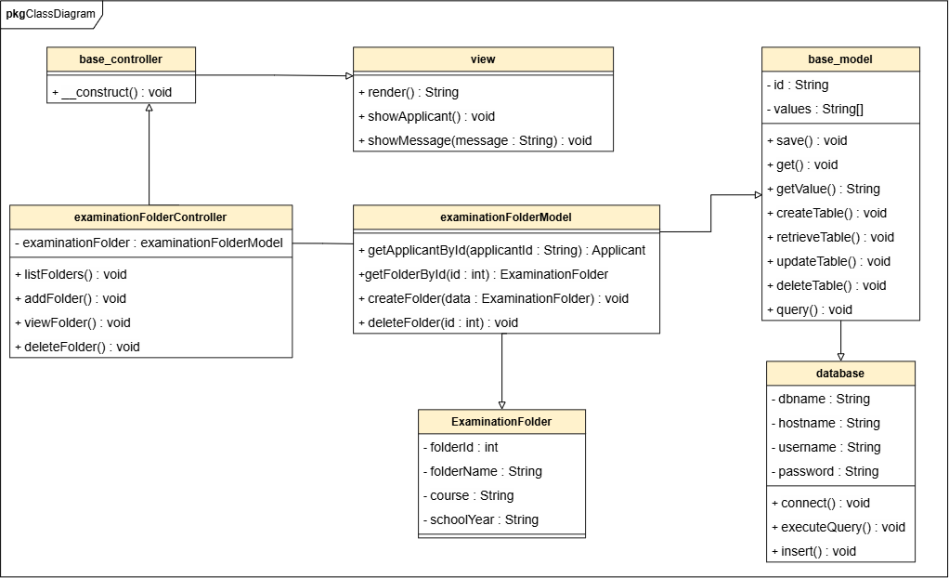
Figure 5.0 Examination Folder Class Diagram

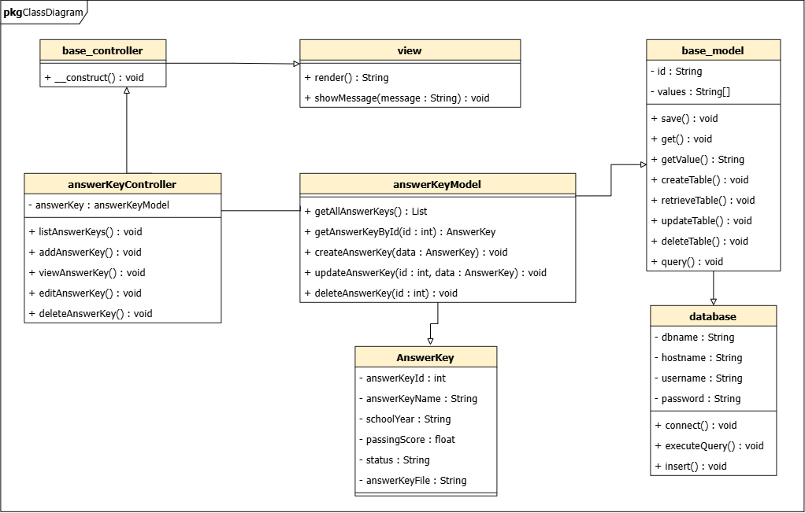
2.1.6. Answer Key - A class diagram that depicts the structure of functions used to create, view, update, and manage examination answer keys, including their passing scores, school years, statuses, and uploaded answer key files.
Figure 6.0 Answer Key Class Diagram
2.1.7. Answer Sheet - A class diagram that depicts the structure of functions used to scan, recognize, validate, and store an applicant’s marked answers from the examination answer sheet.
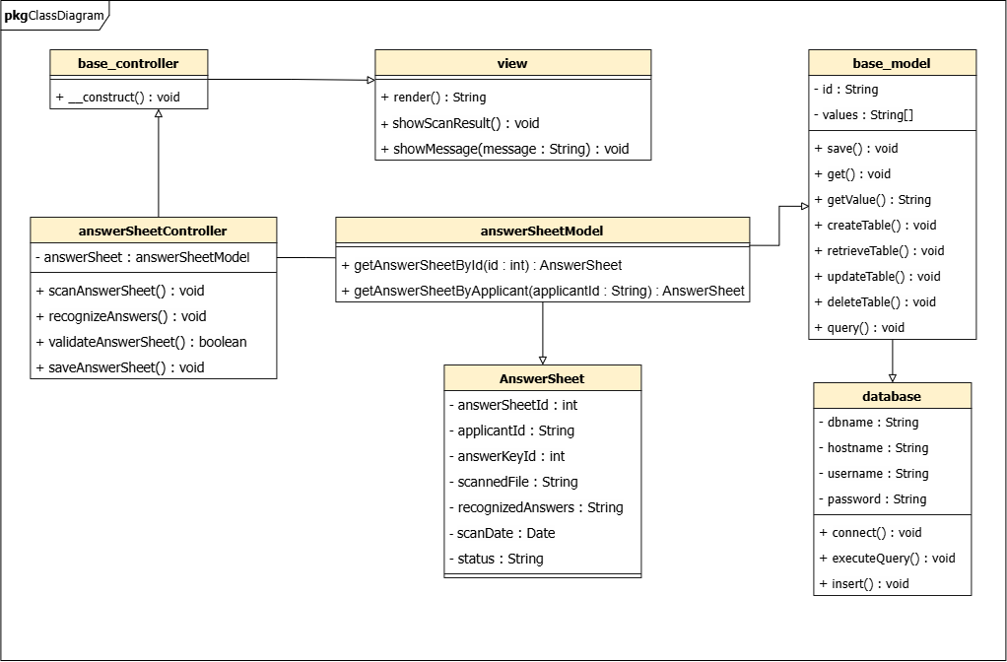
Figure 7.0 Answer Sheet Class Diagram

2.1.8. Examination Result – A class diagram that depicts the structure of functions used to retrieve, search, and display an applicant’s examination result, including the score and examination status.
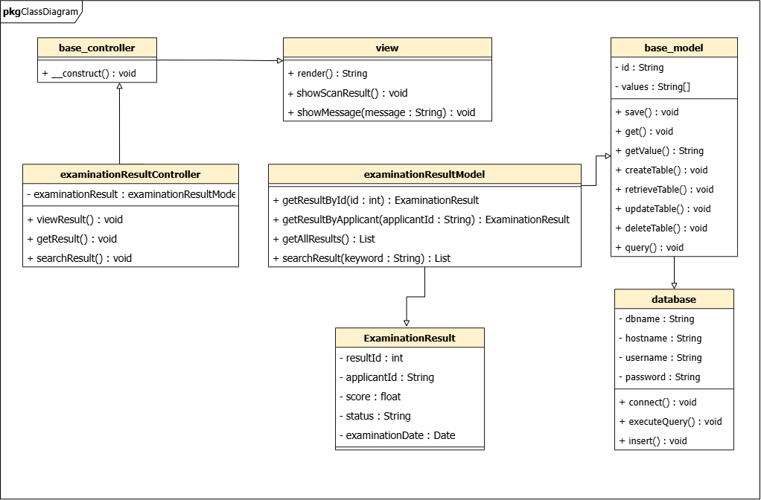
Figure 8.0 Examination Result Class Diagram
2.1.9. AI-based Answer Sheet Recognition Home Scanner – A class diagram that depicts the structure of functions used to capture, process, recognize, validate, and store the marked answers from an applicant’s examination answer sheet.
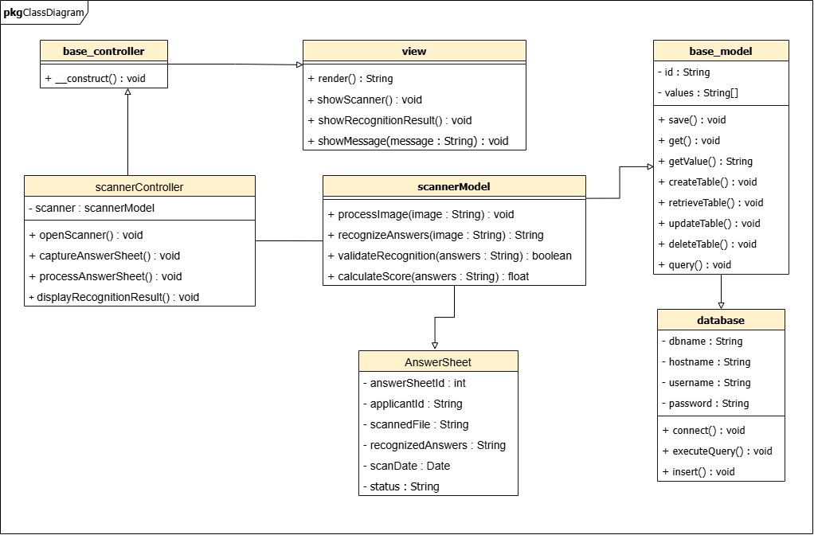
Figure 9.0 AI-based Answer Sheet Recognition Home Scanner Class Diagram

Data Design

Data Description
The implementation contains 11 domain database tables. Tables 2.0-12.0 below describe those tables; Table 1.0 is the definitions glossary, not a database table. Section-aware answer data uses the canonical IDs inductive, math, english, science, and aptitude.
    - Answer Key Items
Table Name: tbl_answer_key_items
Table Description: Table where individual answer-key items are stored, including canonical section ID, section-local item number, correct answer, and points per item.
Primary Key: id
Foreign Key: answer_key_id references tbl_answer_keys(id)
Fieldname | Data Type | Length | Description
id | int | 11 | Field that holds the unique record number for the answer key item.
answer_key_id | int | 11 | Field that holds the ID of the answer key this item belongs to.
section | varchar | 100 | Canonical section ID (inductive, math, english, science, or aptitude). Item numbers restart at 1 in each section.
item_number | int | 11 | Field that holds the item number of the examination question.
correct_answer | varchar | 5 | Correct answer A-E, constrained by section: inductive accepts A-E; all other sections accept A-D.
points | decimal | 5,2 | Field that holds the point value assigned to this item.
created_at | timestamp |  | Field that holds the timestamp when the answer key item was created.
updated_at | timestamp |  | Field that holds the timestamp when the answer key item was last updated.

Table 2.0 Answer Key Items

    - Answer Keys

Table Name: tbl_answer_keys
Table Description: Table where the official answer keys for different examinations are stored.
Primary Key: id
Foreign Key: created_by references tbl_users(id)

Fieldname | Data Type | Length | Description
id | int | 11 | Field that holds the unique record number for the answer key.
exam_title | varchar | 255 | Field that holds the title or identifier for the examination.
passing_score | decimal | 5,2 | Field that holds the minimum score required to pass the examination.
school_year | varchar | 50 | Field that identifies the school year for which the answer key is valid.
status | varchar | 50 | Field that holds the status of the answer key (e.g., 'Active', 'Inactive').
file_path | varchar | 255 | Field that holds the file path to the uploaded answer key file (if any).
created_by | int | 11 | Field that holds the user ID of the administrator who created the answer key.
created_at | timestamp |  | Field that holds the timestamp when the answer key was created.
updated_at | timestamp |  | Field that holds the timestamp when the answer key was last updated.

Table 3.0 Answer Keys

    - Answer Sheets
Table Name: tbl_answer_sheets
Table Description: Table where the metadata and images of scanned answer sheets are stored for processing and archival.
Primary Key: id
Foreign Key: applicant_id references tbl_examination_applicants(id)
Fieldname | Data Type | Length | Description
id | int | 11 | Field that holds the unique record number for the answer sheet.
applicant_id | int | 11 | Field that holds the ID of the applicant who owns this answer sheet.
image_path | varchar | 255 | Field that holds the file path to the stored answer sheet image.
image_hash | varchar | 255 | Field that holds a hash value of the image for integrity verification.
processed_at | datetime |  | Field that holds the timestamp when the answer sheet was processed by the system.
created_at | timestamp |  | Field that holds the timestamp when the answer sheet record was created.
updated_at | timestamp |  | Field that holds the timestamp when the answer sheet record was last updated.

Table 4.0 Answer Sheets

    - Applicant Answers
Table Name: tbl_applicant_answers
Table Description: Table where each applicant answer is stored with its canonical section ID, section-local item number, marked answer, and correctness result.
Primary Key: id
Foreign Key: sheet_id references tbl_answer_sheets(id)
Fieldname | Data Type | Length | Description
id | int | 11 | Field that holds the unique record number for the applicant answer.
sheet_id | int | 11 | Field that holds the ID of the answer sheet this answer belongs to.
section | varchar | 100 | Canonical section ID (inductive, math, english, science, or aptitude). Item numbers restart at 1 in each section.
item_number | int | 11 | Field that holds the item number of the examination question.
marked_answer | varchar | 5 | Detected answer A-E or null when blank, constrained by the option range of the recorded section.
is_correct | boolean | 1 | Field that indicates whether the applicant's answer is correct. 1 for correct, 0 for incorrect.
created_at | timestamp |  | Field that holds the timestamp when the applicant answer was created.
updated_at | timestamp |  | Field that holds the timestamp when the applicant answer was last updated.

Table 5.0 Applicant Answers

    - Audit Logs
Table Name: tbl_audit_logs
Table Description: Table where all significant user actions are logged for security, traceability, and accountability.
Primary Key: id
Foreign Key: user_id references tbl_users(id)
Fieldname | Data Type | Length | Description
id | int | 11 | Field that holds the unique record number for the audit log.
user_id | int | 11 | Field that holds the ID of the user who performed the action.
action | varchar | 50 | Field that holds the type of action performed (e.g., 'LOGIN', 'SCAN_ANSWER_SHEET', 'CREATE_USER').
table_name | varchar | 100 | Field that holds the name of the database table affected by the action.
record_id | int | 11 | Field that holds the ID of the specific record affected.
ip_address | varchar | 45 | Field that holds the IP address from which the action was performed.
created_at | timestamp |  | Field that holds the timestamp when the action was logged.

Table 6.0 Audit Logs

    - Examination Folders
Table Name: tbl_examination_folders
Table Description: Table where the organizational folders for examination results are stored, typically categorized by course and school year.
Primary Key: id
Foreign Key: created_by references tbl_users(id)
Fieldname | Data Type | Length | Description
id | int | 11 | Field that holds the unique record number for the folder.
course | varchar | 100 | Field that holds the course name or code for the folder.
school_year | varchar | 50 | Field that identifies the school year for the folder.
description | text |  | Field that holds a detailed description or additional notes for the folder.
status | varchar | 50 | Field that holds the status of the folder (e.g., 'Active', 'Archived').
created_by | int | 11 | Field that holds the user ID of the administrator who created the folder.
created_at | timestamp |  | Field that holds the timestamp when the folder was created.
updated_at | timestamp |  | Field that holds the timestamp when the folder was last updated.

Table 7.0 Examination Folders

    - Examination Result
Table Name: tbl_examination_results
Table Description: Table where the final computed scores and statuses for each applicant are stored.
Primary Key: id
ForeignKey:applicant_id references tbl_examination_applicants(id), answer_key_id references tbl_answer_keys(id), computed_by references tbl_users(id)
Fieldname | Data Type | Length | Description
id | int | 11 | Field that holds the unique record number for the result.
applicant_id | int | 11 | Field that holds the ID of the applicant.
answer_key_id | int | 11 | Field that holds the ID of the answer key used for scoring.
score | decimal | 5,2 | Field that holds the computed percentage or raw score of the applicant.
status | varchar | 50 | Field that holds the final status of the applicant (e.g., 'Passed', 'Failed').
total_items | int | 11 | Field that holds the total number of items in the examination.
correct_count | int | 11 | Field that holds the number of correct answers.
incorrect_count | int | 11 | Field that holds the number of incorrect answers.
passing_score | decimal | 5,2 | Field that holds the passing score for reference.
computed_by | int | 11 | Field that holds the user ID of the staff who computed the result.
computed_at | datetime |  | Field that holds the timestamp when the score was computed.
created_at | timestamp |  | Field that holds the timestamp when the result record was created.
updated_at | timestamp |  | Field that holds the timestamp when the result record was last updated.

Table 8.0 Examination Result

    - OMR Processing Jobs
Table Name: tbl_omr_processing_jobs
Table Description: Table where batch processing jobs for the OMR/AI module are queued and tracked.
Primary Key: id
Foreign Key: sheet_id references tbl_answer_sheets(id), user_id references tbl_users(id)
Fieldname | Data Type | Length | Description
id | int | 11 | Field that holds the unique record number for the processing job.
sheet_id | int | 11 | Field that holds the ID of the answer sheet being processed.
user_id | int | 11 | Field that holds the ID of the user who initiated the processing job.
status | varchar | 50 | Field that holds the job's status (e.g., 'Queued', 'Processing', 'Completed', 'Failed').
queue_position | int | 11 | Field that holds the position of the job in the processing queue.
started_at | datetime |  | Field that holds the timestamp when the job started processing.
completed_at | datetime |  | Field that holds the timestamp when the job was completed.
error_message | text |  | Field that holds the error message if the job failed during processing.
retry_count | int | 11 | Field that holds the number of times the job has been retried.
created_at | timestamp |  | Field that holds the timestamp when the job was created.
updated_at | timestamp |  | Field that holds the timestamp when the job was last updated.

Table 9.0 OMR Processing Jobs

    - System Settings
Table Name: tbl_settings
Table Description: Table where the system-wide configuration settings are stored.
Primary Key: id
Foreign Key: updated_by references tbl_users(id)
Fieldname | Data Type | Length | Description
id | int | 11 | Field that holds the unique record number for the setting.
setting_key | varchar | 100 | Field that holds the unique key for the setting (e.g., 'system_name', 'max_retries').
setting_value | text |  | Field that holds the value for the setting.
description | varchar | 255 | Field that holds a description of what the setting does.
updated_by | int | 11 | Field that holds the user ID of the administrator who last updated the setting.
created_at | timestamp |  | Field that holds the timestamp when the setting was created.
updated_at | timestamp |  | Field that holds the timestamp when the setting was last updated.

Table 10.0 System Settings

    - Users

Table Name: tbl_users
Table Description: Table where the system user accounts are stored.
Primary Key: id
Foreign Key: None
Fieldname | Data Type | Length | Description
id | int | 11 | Field that holds the unique record number for the user.
username | varchar | 100 | Field that holds the unique username used for logging in.
email | varchar | 100 | Field that holds the user's email address.
password_hash | varchar | 255 | Field that holds the hashed password for secure authentication.
full_name | varchar | 255 | Field that holds the user's full name.
role | varchar | 50 | Field that holds the user's role (e.g., 'Administrator', 'Staff') for access control.
is_active | boolean | 1 | Field that holds the status of the user account. 1 for active, 0 for inactive.
last_login | datetime |  | Field that holds the timestamp of the user's last successful login.
created_at | timestamp |  | Field that holds the timestamp when the user account was created.
updated_at | timestamp |  | Field that holds the timestamp when the user account was last updated.

Table 11.0 Users

    - Exam Applicants
Table Name: tbl_examination_applicants
Table Description: Table where the information of applicants taking the entrance examination is recorded for processing.
Primary Key: id
ForeignKey: folder_id references tbl_examination_folders(id), answer_key_id references tbl_answer_keys(id), created_by references tbl_users(id)
Fieldname | Data Type | Length | Description
id | int | 11 | Field that holds the unique record number for the applicant.
folder_id | int | 11 | Field that holds the folder ID where this applicant's result will be stored.
answer_key_id | int | 11 | Field that holds the ID of the answer key to be used for scoring this applicant.
applicant_name | varchar | 255 | Field that holds the applicant's full name.
examination_date | date |  | Field that holds the date the applicant took the examination.
status | varchar | 50 | Field that holds the processing status of the applicant (e.g., 'Pending', 'Processed').
created_by | int | 11 | Field that holds the user ID of the staff who registered the applicant.
created_at | timestamp |  | Field that holds the timestamp when the applicant record was created.
updated_at | timestamp |  | Field that holds the timestamp when the applicant record was last updated.

Table 12.0 Exam Applicants

Entity-Relationship Diagram

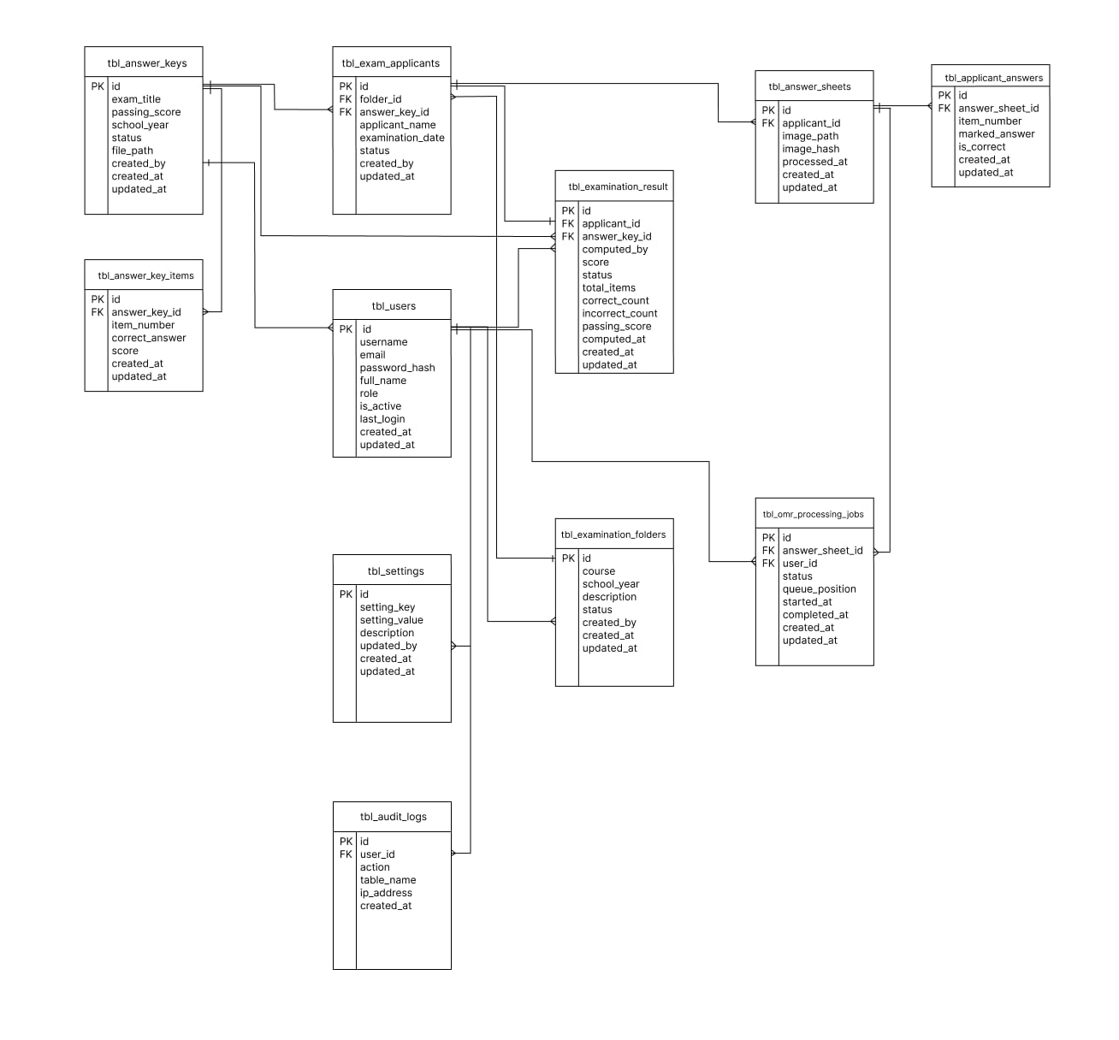
Figure 10.0 Entity-Relationship Diagram

Detailed Design

  - Login Sequence Diagram
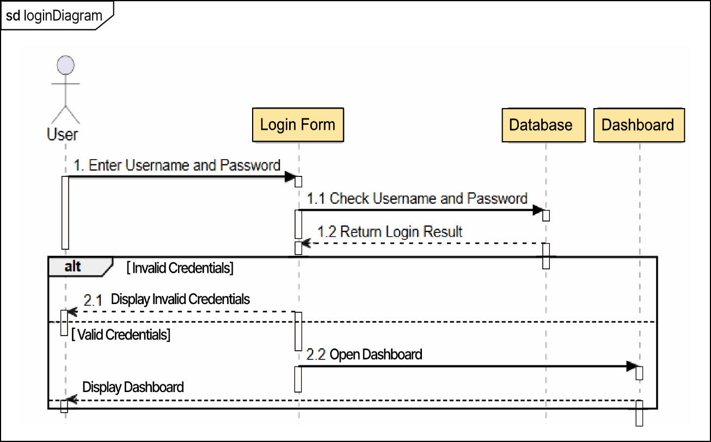
Figure 11.0 Login Sequence Diagram

  - Dashboard Sequence Diagram

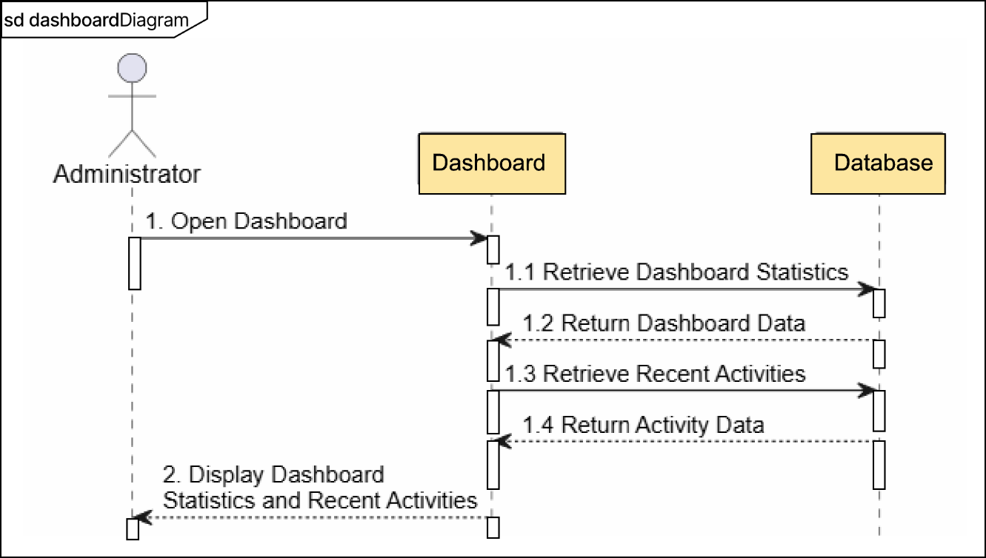
Figure 12.0 Dashboard Sequence Diagram
  - User Account Sequence Diagram
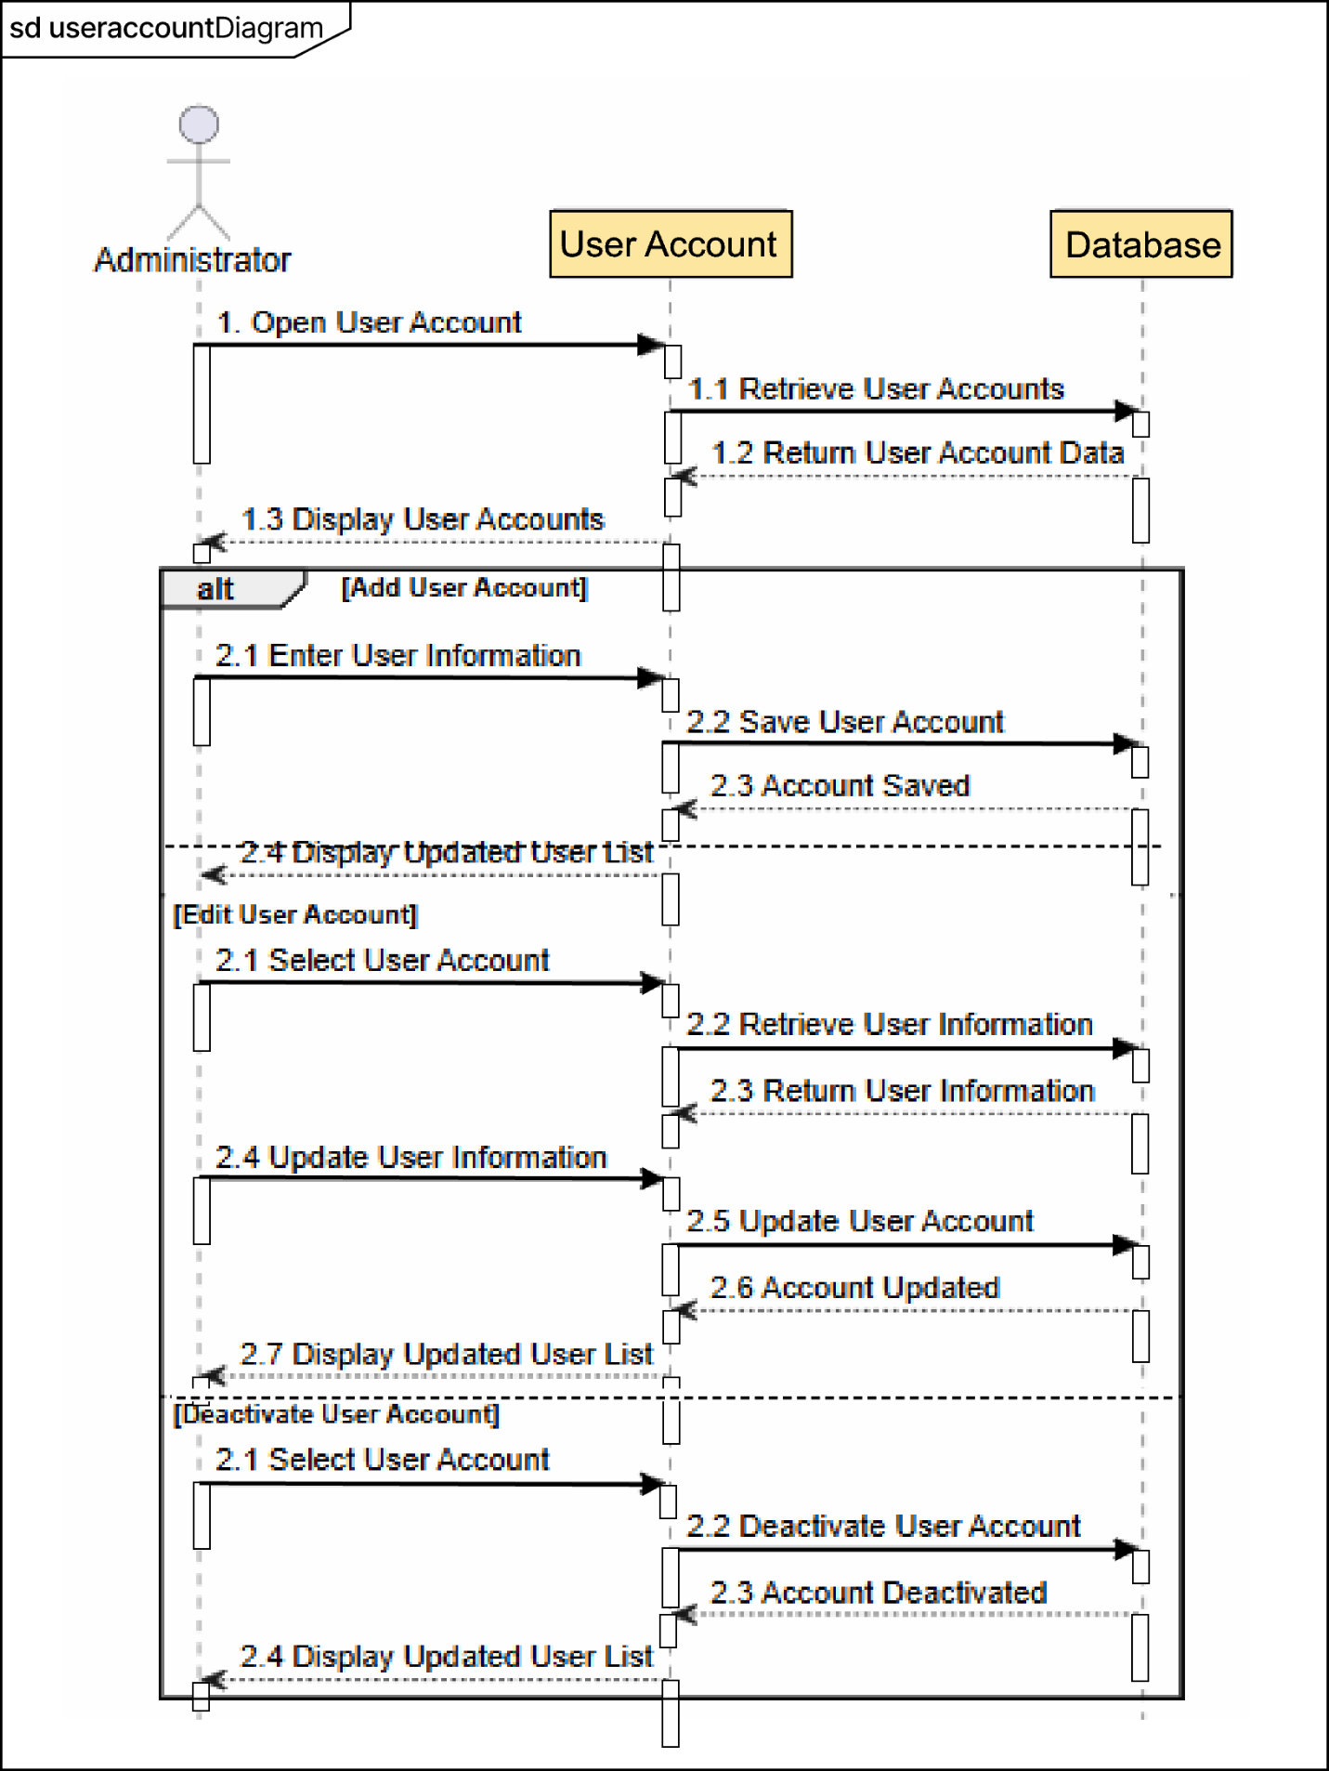
Figure 13.0 User Account Sequence Diagram

  - Identify Applicant Sequence Diagram
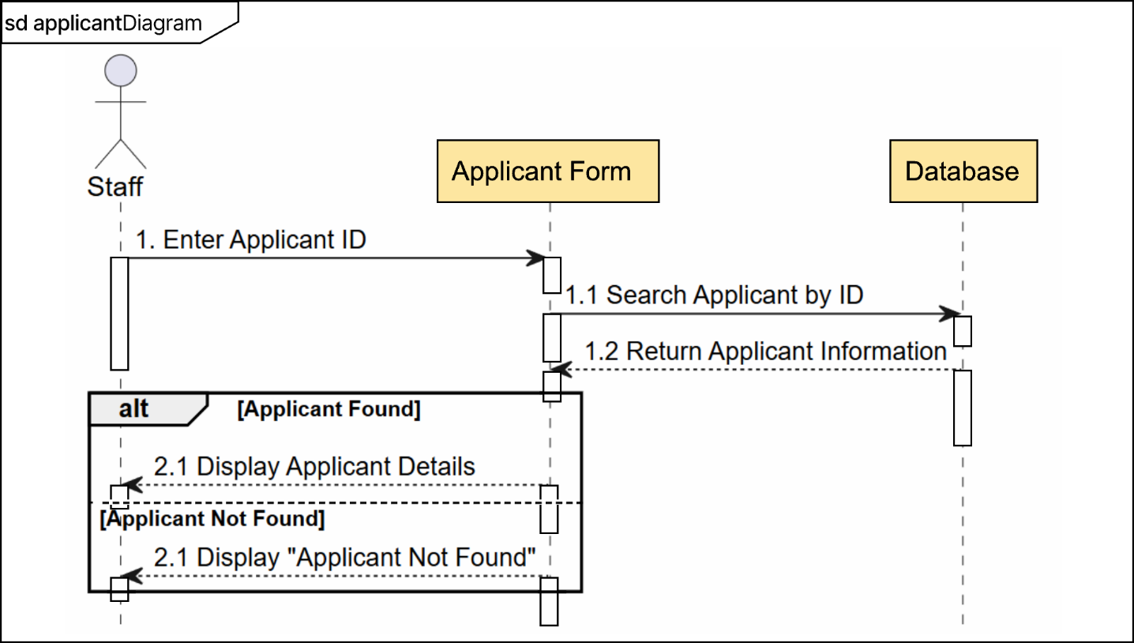
Figure 14.0 Identify Applicant Sequence Diagram

  - Examination Folder Sequence Diagram

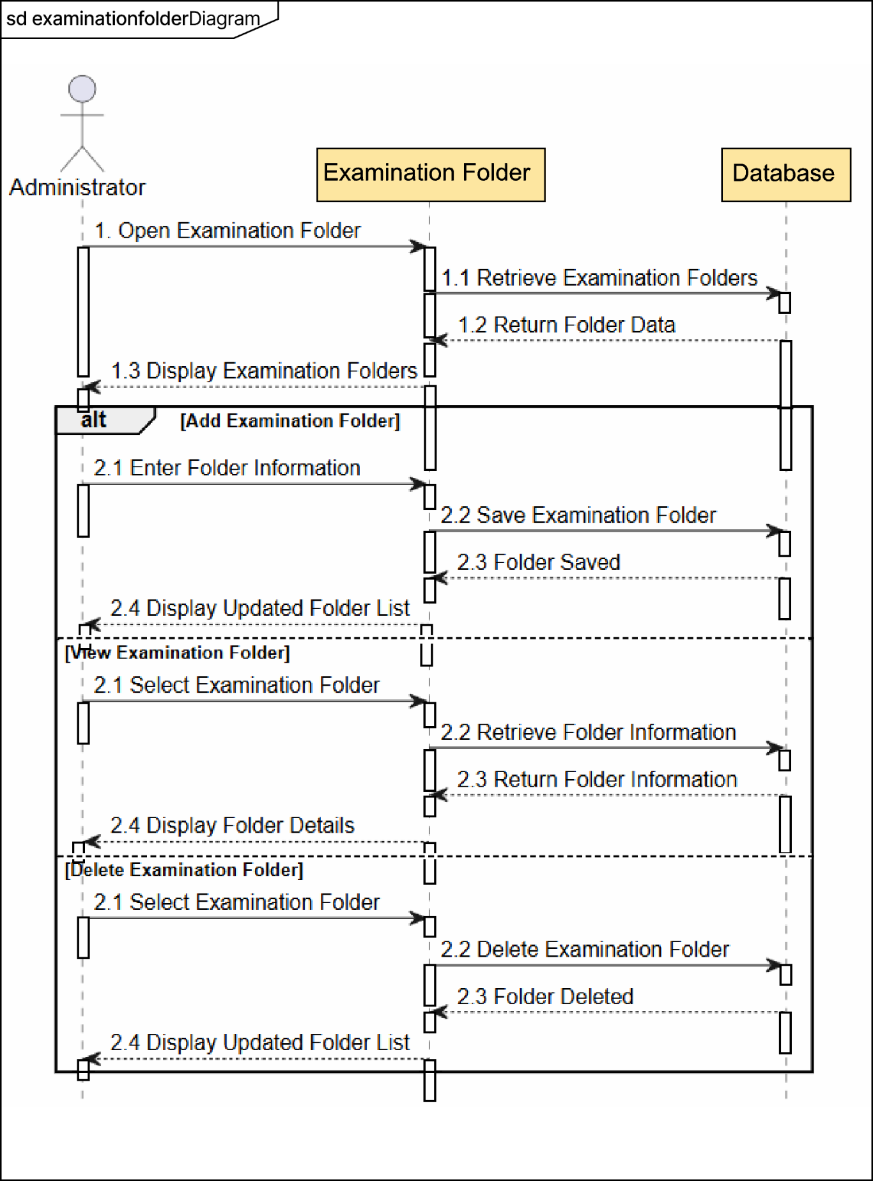
Figure 15.0 Examination Folder Sequence Diagram

  - Answer Key Sequence Diagram
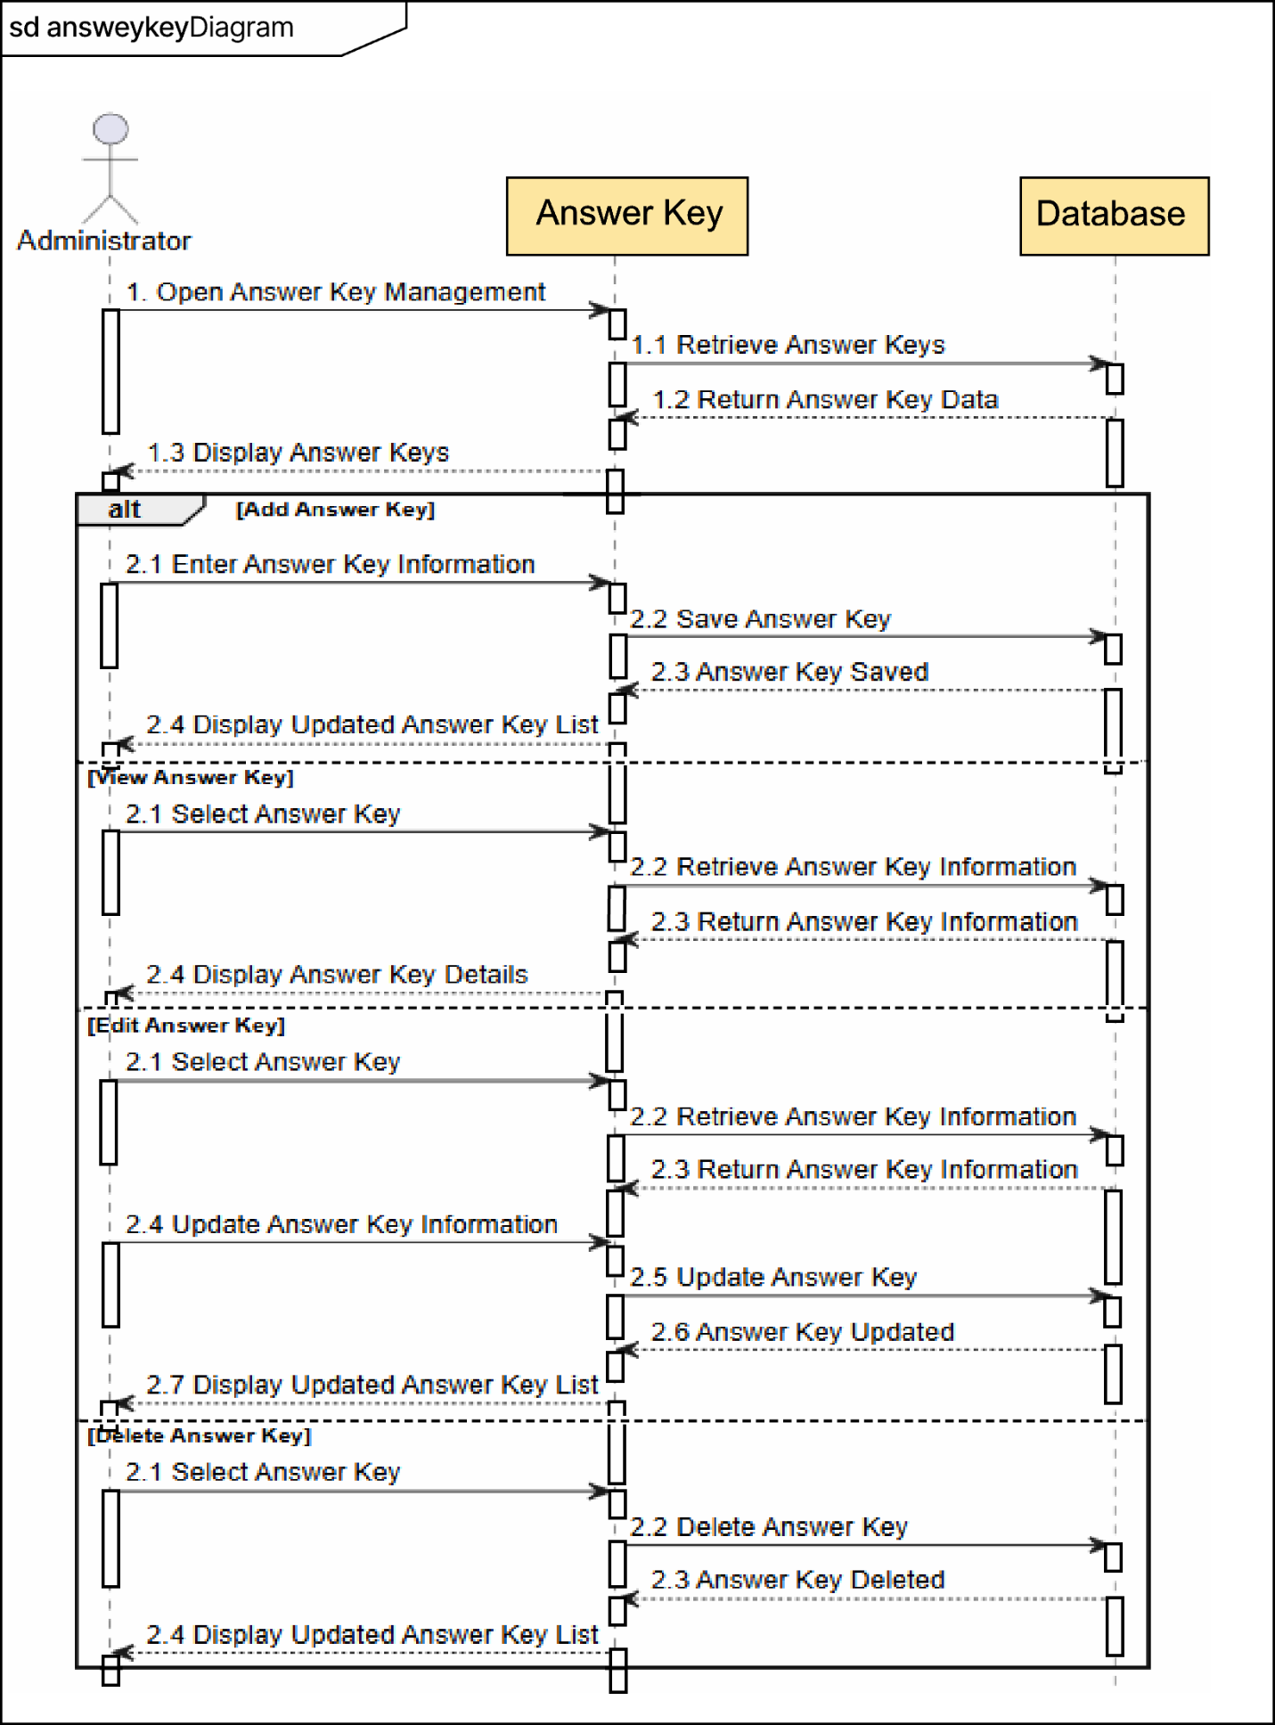

Figure 16.0 Answer Key Sequence Diagram

  - Answer Sheet Sequence Diagram

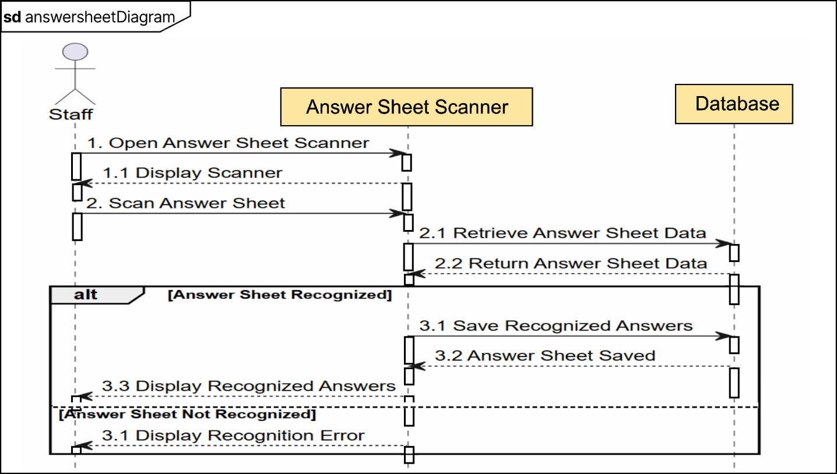
Figure 17.0 Answer Sheet Sequence Diagram

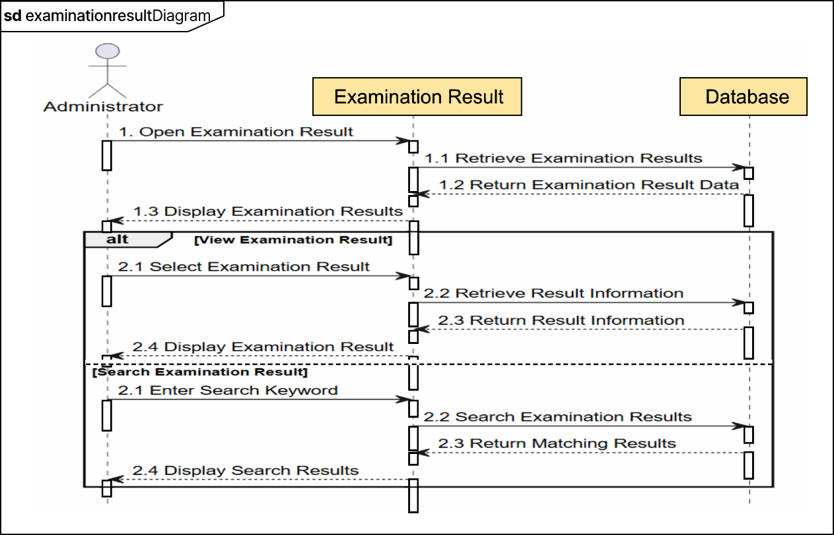
  - Examination Result Sequence Diagram
Figure 18.0 Examination Result Sequence Diagram

  - AI Based Answer Sheet Recognition Home Scanner
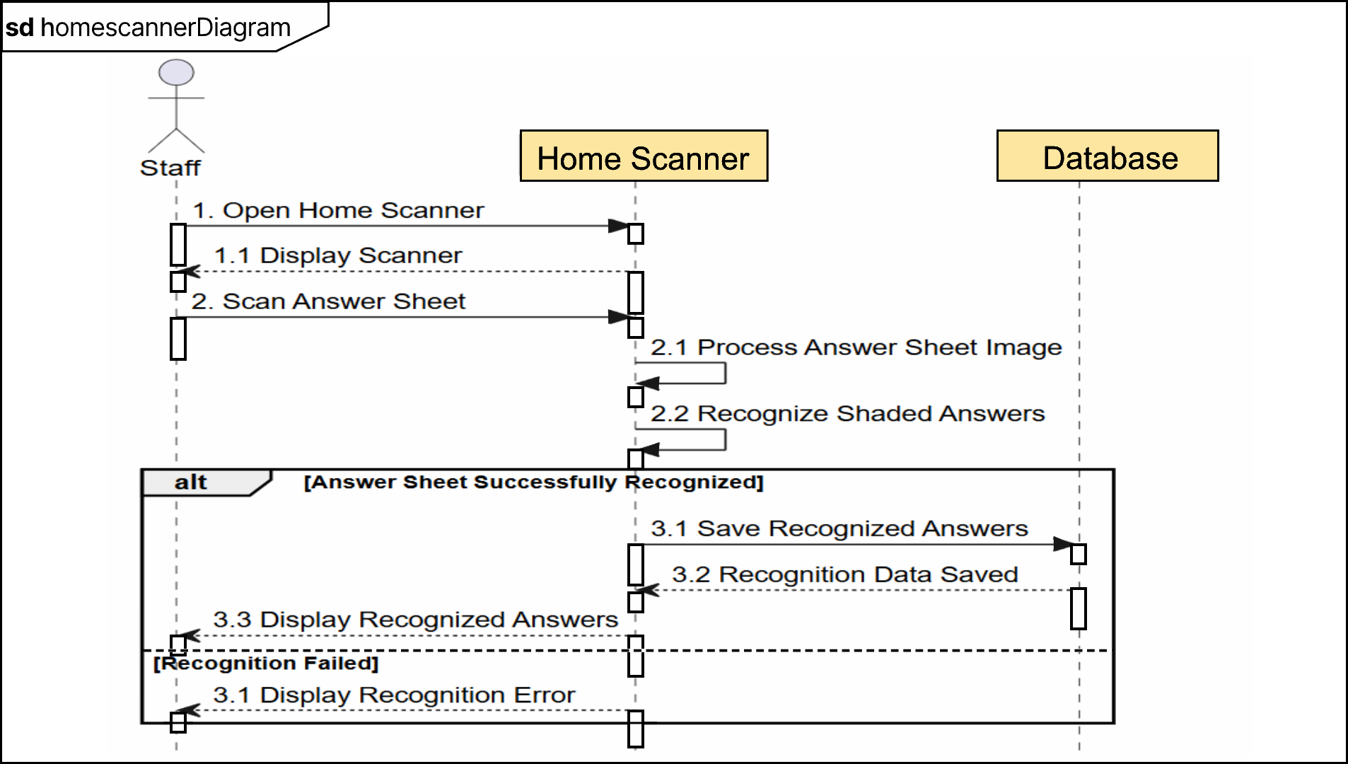

Figure 19.0 AI Based Answer Sheet Recognition Home Scanner

Human Interface Design

OMR Service Implementation Update (November 3, 2026)
The implemented Python OMR service uses a versioned reference and SIFT registration with a quadrilateral-warp fallback. It refines the printed bubble lattice without answer truth, extracts exactly 410 grayscale 44 x 44 crops, and classifies every bubble using the verified BubbleCNN checkpoint.
The production decision layer converts bubble classes into 100 section-local item states. Exactly one shaded bubble is an answer; blank items are incorrect; multiple shades and detected erasures are invalid; and low-confidence single answers are retained with an explicit flag.
The scoring engine validates a complete 100-item answer key, canonical section IDs, option ranges, duplicate and missing items, points, and passing score. It returns per-item correctness, weighted points, percentage, correct and incorrect counts, and Passed or Failed status through POST /recognize.
Validation reproduced all 10,250 locked dataset crops exactly. With an erasure probability threshold selected only on validation sheets, exact item recognition is 97.04 percent across 2,500 labeled items and 97.0 percent on the locked three-sheet test split. Laravel queue consumption, database persistence, audit logging, and additional mobile-camera field validation remain integration work.

Laravel-OMR Integration Update (November 3, 2026)
The Laravel backend now automatically resolves the single complete active answer key when an applicant is identified. Staff and mobile clients cannot choose an answer key. Once a key is assigned, its scoring metadata and items cannot be edited or deleted, preserving reproducibility for queued and historical examinations.
Answer-sheet upload stores the image on Laravel's private disk, creates a domain processing record and dispatches ProcessOmrSheet to the database-backed omr queue. The worker serializes the bound 100-item key, calls the private Python recognition endpoint, retries transient service failures with backoff, and records permanent capture or contract rejection without saving partial results.
Before persistence, Laravel independently validates all 100 recognition and scoring items against the bound key, recomputes weighted points, percentage, counts, and Passed or Failed status, and rejects inconsistent responses. Successful processing atomically stores per-item recognition status, confidence, flags, correctness, points, result totals, model and registration metadata, sheet and applicant state, job completion, and an audit event.
Docker Compose includes a dedicated OMR queue worker. Mobile clients upload only applicant_id and the captured image, poll the authenticated job endpoint, and may replace a failed capture with a new image.

